VPC USING BASTION SERVER
- VPC with Bastion Server
VPC & Subnet Design
VPC CIDR: 10.0.0.0/16
Public Subnet (Bastion Server): 10.0.1.0/24
Private Subnet (Database Server): 10.0.2.0/24
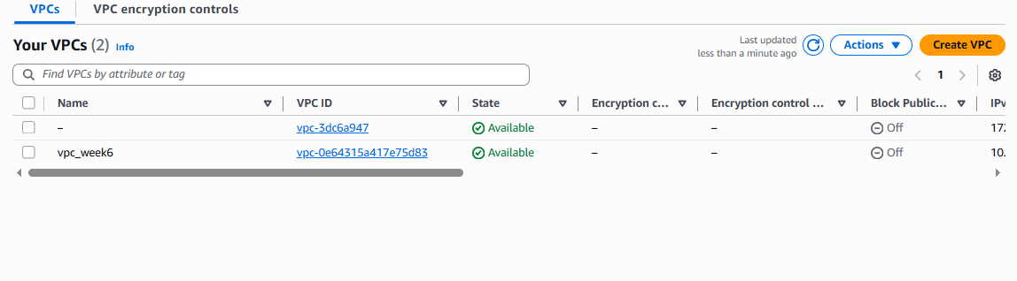
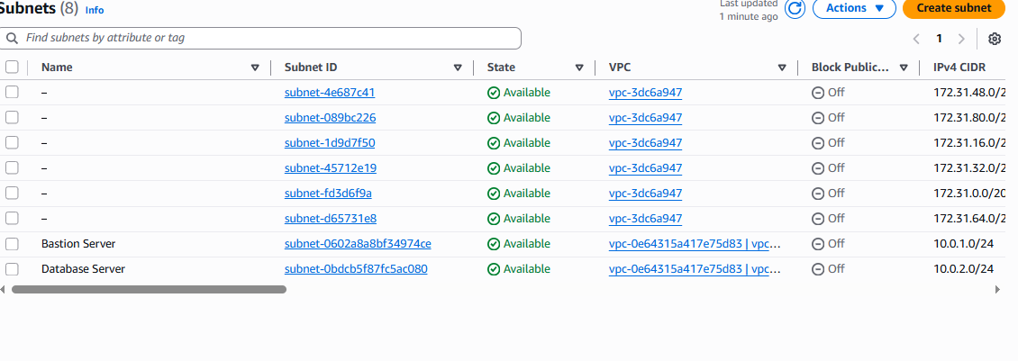
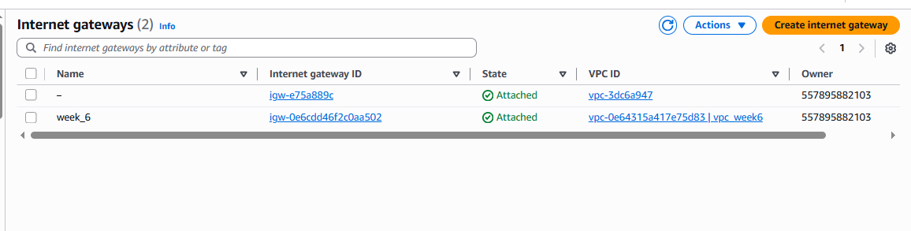
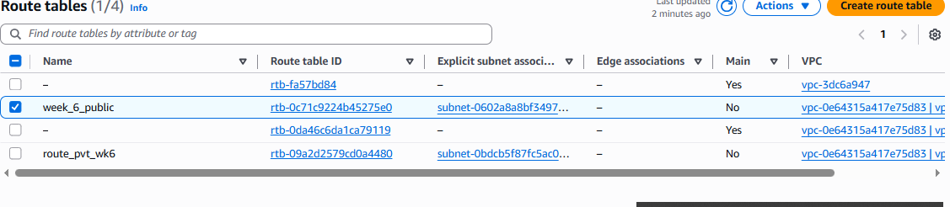

- Security Group Configuration (VERY IMPORTANT)
Bastion Server Security Group (Public Subnet)
Allows SSH (22) from:My IP (Database Administrator)
Database Server Security Group (Private Subnet)
Allows MySQL / Aurora (3306) from: custom 10.0.1.0/24 (Public subnet / Bastion subnet)
Allows SSH (22) from: custom Private IP of Bastion Server
Does NOT allow public access
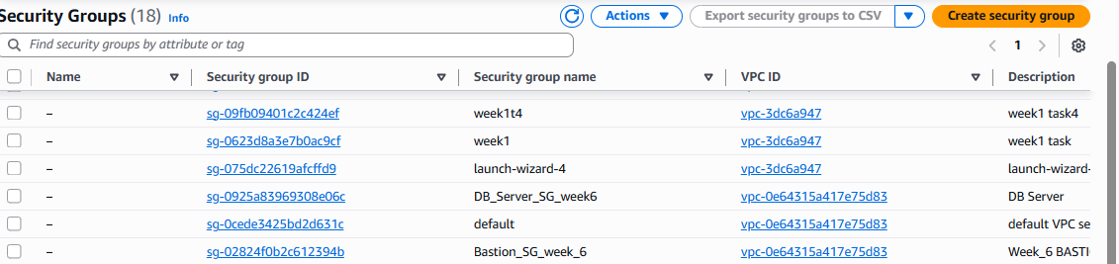

- Security Outcome
Database server is NOT publicly accessible
Only Bastion server can connect to DB server using SSH
External users cannot access DB directly
- EC2 Instance Creation
Bastion Server
Subnet: Public Subnet (10.0.1.0/24)
Key pair: bastion.pem
Operating System: Ubuntu
Database Server
Subnet: Private Subnet (10.0.2.0/24)
Key pair: dbserver.pem
Operating System: Ubuntu
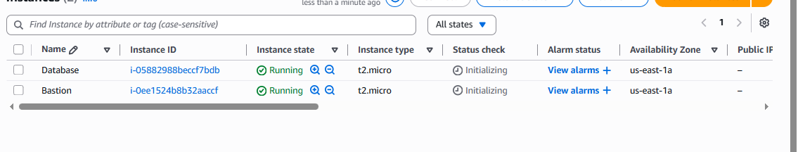

- Copy DB Server Key to Bastion Server
Database server is in private subnet
Direct SSH from local system is NOT possible
DB server key must be copied to Bastion server
Command (PowerShell):
scp –i bastion.pem dbserver.pem ubuntu@<BASTION_PUBLIC_IP>:/home/ubuntu/
File is copied securely using SCP
dbserver.pem will now be available inside Bastion server
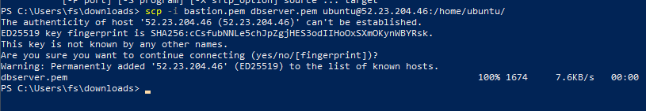

- Connect to Bastion Server
SSH Command:
ssh -ibastion.pem ubuntu@<BASTION_PUBLIC_IP>
Verify key files:
ls
Output:
bastion.pem
dbserver.pem
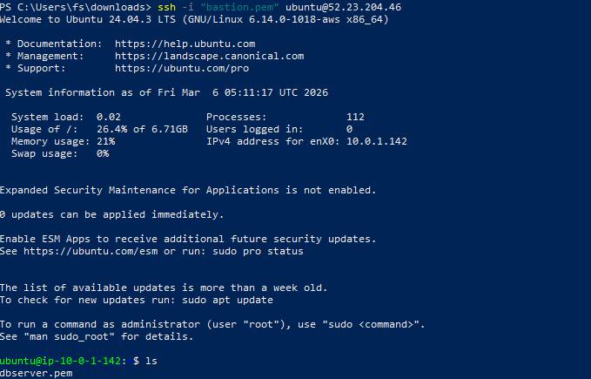

- Connect from Bastion to Database Server
SSH from Bastion:
ssh -idbserver.pem ubuntu@10.0.2.x
Connection to DB server is successful
Database administrator can now:
Update database configurations
Install required packages-------problem occurs
Restart MySQL service
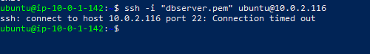
VPC USING NAT GATEWAY
- In the above steps it clear there is no internet access, if we want to install or update anything in the instances present in private subnet.
- Network Address Translator (NAT Gateway) will solve this problem. Goto NAT Gateway in the left side menu bar of VPC and click on create NAT gateway.
- Give the Nat gateway name, select your VPC, scroll down and click create NAT gateway.
- So Now create a route for accessing NATGateway. Goto Route table click on create route table and give the route table name as bastion route , select our customized vpc and click on create route.
- Select the route, click on actions, goto edit subnet associations and add private subnet to this bastion route.
- Againgoto actions and click on edit routes, attach NAT Gateway with 0.0.0.0/0, select your NAT gateway name in the drop down menu and click on save changes.
- Now check in the dbsever you will internet in ec2 of private subnet.
- 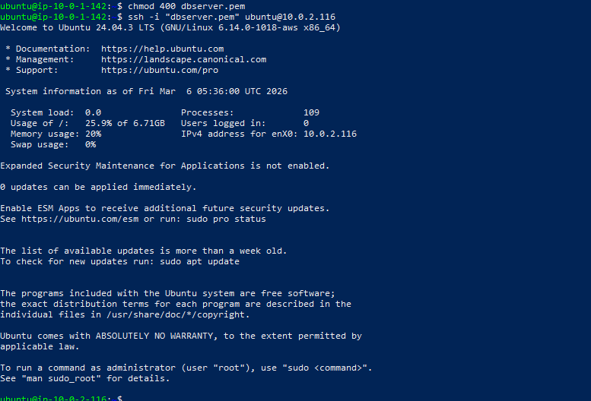

SCENARIO BASED QUESTIONS

- You have multiple private subnets in different AZs. Should you use one NAT Gateway or multiple NAT Gateways? Explain your design choice.
ANS: Using multiple NAT gateways, one for each AZ.
- Your private subnet instances can reach the internet, but the NAT Gateway shows no traffic.
What could be the possible reasons?
ANS: private subnet route table is not targeting NAT gateway.
- A NAT Gateway was accidentally created in a private subnet instead of a public subnet.
What problem will occur, and how would you fix it?
ANS: NAT gateway won’t work as it needs an IGW.
- An application running in a private subnet requires outbound access only to a few trusted external services.
How would you restrict traffic while still using a NAT Gateway?
ANS: Using Security Groups.
- Multiple teams share a single VPC and NAT Gateway. One team’s traffic is affecting others.
How would you redesign the NAT Gateway setup to isolate traffic?
ANS: Creating separate NAT gateways
- You can successfully SSH into a private EC2 instance using a Bastion server, but yum update / apt update fails inside the private instance. Why?
ANS: Private Subnet route table not pointing to NAT gateway.
- Private EC2 instances can access the internet through a NAT Gateway, but administrators cannot SSH into them using the Bastion server.
ANS: Security group inbound rule not having SSH port 22
- A Bastion server and NAT Gateway are both created in a private subnet by mistake. What impact does this cause?
ANS: Bastion Server can’t be accessed from the internet.
- SSH access to the Bastion server works, but SSH from Bastion to the private EC2 fails. Why?
ANS: Private Subnet SG inbound rule doesn’t allow SSH from IP of Bastion Private IP, this can be done by using SG of Bastion Server.
- A student claims that a Bastion server alone is enough to provide internet access to private instances. Why is Bastion not a replacement for NAT Gateway?
ANS: Bastion only allows for private instances, NAT can work for other instances also.

